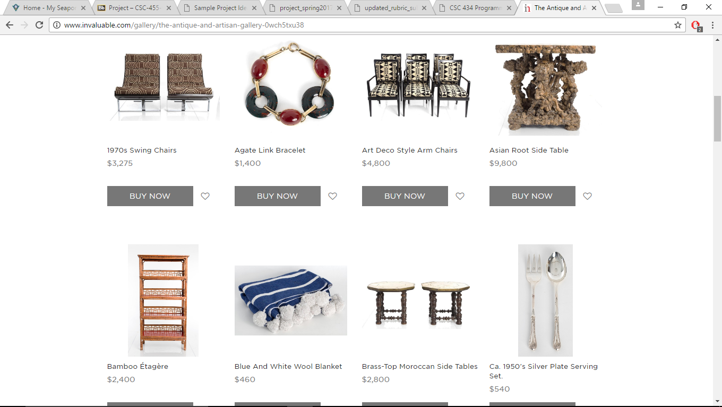

Art Gallery

With Functioning Shop option

Jamie Sparrow | Alejandro Pena | Robert Arnold | Dillon Harless

The team coordinated with a client who desires an online art gallery where people can view his friend’s artwork and purchase pieces online. We plan to create the back end in SQL using MySql and a multi-platform website paired with a sister Android app. Customers will create accounts, save shopping lists, and purchase things. We also plan to have an admin log-in page.